CALL FOR PROJECTS 2026

- PROJECT INFORMATION

- Main applicant, title of the project, scientific abstract & lay summary
- Project description
- Budget

Important administrative information

- Ethical questions
Does your project require the approval of an ethics committee? If so, send an e-mail to info@belgiandermatology.be as soon as you have received an opinion from that committee. The project cannot start without a formal approval of the ethics committee(s).

- Overhead
No overhead can be deducted from this grant

- Potential beneficiaries
The grant will only fund Belgian Dermatologists or Dermatology residents working in a hospital or other care organization (e.g. private practice). For-profit organizations (e.g. pharmaceutical companies) can be part of a research team but are excluded from funding.

- Other funding resources
Do you receive any commercial or other sponsoring related to this research project, or to consumables, materials etc. that will be used in this project? Please mention the type and the amount of the sponsoring(s) in your application and the budget sheat.

- Research Integrity
Funded researchers are expected to fully comply with all institutional rules and regulations that apply in terms of research integrity.
In case of integrity breach suspicion or allegation, appropriate measures will be taken.

- Format
Headlines: Calibri (body), bold, 20 pts
Text fonts: Calibri (body), 11 pts.

- Main applicant, title of the project, scientific abstract & lay summary

Main Applicant
Last name, first name, academic title(s)
Employer organization
Street, Nr., postcode, City
Email

Title of the project
Lorem ipsum…

Lay summary (250 words maximum)

Lorem ipsum

Scientific abstract (Background, Hypothesis/ aims, working program, expected results, max 1 A4):

Lorem Ipsum…

- Project description (max 8 A4)

Project description

- Objectives

Objective 1:
Lorem Ipsum

- Project plan & various steps (including a timeline)

Project plan

Timeline:

Example:
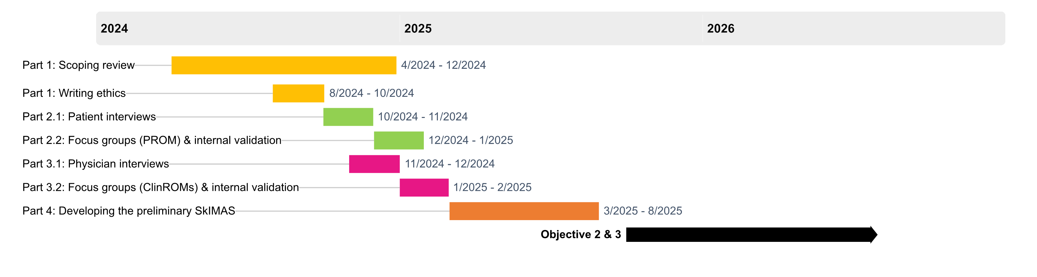

- Expected outcomes & potential impact of the results:
Lorem ipsum…

Scientific rationale & added value compared to existing knowledge/clinical practices

Lorem ipsum…

Explain how the project responds to medical, allied health or psychosocial issues related to dermatological diseases and how this need was identified.

Lorem ipsum…

Explain how the patient perspective is taken into account (or not taken into account) in the design of the project.

Lorem ipsum…

Which stakeholders will you involve in the research and explain how their expertise will be taken into account.

Lorem ipsum…

Include a plan for the implementation of the study results into practice or further research/ development steps

Lorem ipsum…

Are any gender or diversity issues taken into account? If so; how, if not; why?
Lorem ipsum…

Plan for the communication of the study results, in both peer-reviewed and gray communications (including negative results).

Lorem ipsum…

- Budget
Max. one A4 page

Please provide a detailed budget outline, divided into the following categories:
- Human resources Describe the function and qualifications of any personnel that will be supported by the project, identify personnel by name if the person(s) are already known, provide a clear justification for the recruitment of personnel for the project.

- Operational costs Provide details about different cost items to make it clear how you will use the budget. Such cost items can include consumables, publication, travel costs, communications, etc. Take into account that a detailed budget is much more feasible to evaluate than requests for lump sums.

- Other costs associated with the project

- Any available funding for the project Having funds available is not considered a negative point in the evaluation!

- Divide the budget over max. 3 years, per year of the project and per participating research group.

- If this project is part of a larger study, please provide the duration and total budget of the larger study and explain which part(s) of the larger study would be funded by this grant.

Reminder:
Target amount for grants: €15.000
No overhead can be taken on grants

General information
Total cost entire project | Total duration project (years) | Budget already available & by whom | Budget requested to the Fund
€ |  | € | €

Grant support
Description | Amount | Year 1 | Year 2 | Year 3 | TOTAL
- Human resources
 | € | € | € | € | € €
 | € | € | € | € | € €
 | € | € | € | € | € €
- Operational costs
 | € | € | € | € | € €
 | € | € | € | € | € €
 | € | € | € | € | € €
- Other costs
 | € | € | € | € | € €
 | € | € | € | € | € €
 | € | € | € | € | € €
TOTAL | € | € | € | € | € €
Distribution of the budget |  | € | € | € | € €

References (Vancouver style)
Lorem Ipsum

